EXPERIMENT 4– DATA INSPECTION, FILTERING, STATISTICAL ANALYSIS AND CORRELATION

Aim
To perform data inspection, filtering, statistical analysis, visualization, grouping, and correlation analysis on a credit card fraud dataset using Pandas, NumPy, and Matplotlib.

Algorithm
Step 1: Import the required libraries such as Pandas, NumPy, and Matplotlib.
Step 2: Load the credit card fraud dataset from the Excel file using pd.read_excel().
Step 3: Display the first five records of the dataset using df.head().
Step 4: Determine the number of rows and columns using df.shape.
Step 5: Display the data types of all columns using df.dtypes.
Step 6: Inspect the complete structure of the dataset using df.info().
Step 7: Generate descriptive statistical measures using df.describe().
Step 8: Filter transactions where the transaction amount is greater than 500 and store them in high_amount.
Step 9: Sort the dataset based on the transaction amount in descending order using sort_values().
Step 10: Select the top 10 transactions based on transaction amount.
Step 11: Visualize the top 10 transaction amounts using a bar chart.
Step 12: Calculate the mean, median, mode, and standard deviation of the transaction amount.
Step 13: Group the data based on merchant_category and calculate the average transaction amount for each category.
Step 14: Visualize the average transaction amount for each merchant category using a bar chart.
Step 15: Select numerical columns and calculate their correlation matrix using corr().
Step 16: Display the correlation matrix to identify relationships between numerical variables.
Step 17: Create a scatter plot between transaction_hour and amount to visualize their relationship.
Step 18: Display all the generated results and visualizations.
Program:
import pandas as pd
import numpy as np
import matplotlib.pyplot as plt

# Load the Excel dataset
df = pd.read_excel(r"C:\Users\palan\Downloads\credit_card_fraud.xlsx")

# Display first five records
print(df.head())

# Display shape of dataset
print("Shape of Dataset:")
print(df.shape)

# Display data types
print("Data Types:")
print(df.dtypes)

# Display dataset information
print(df.info())

# Display descriptive statistics
print(df.describe())

# Filter transactions with amount greater than 500
high_amount = df[df["amount"] > 500]

print(high_amount)

# Sort dataset by amount in descending order
sorted_df = df.sort_values(
by="amount",
ascending=False
)

print(sorted_df.head())

# Select top 10 transactions
top10 = sorted_df.head(10)

# Plot top 10 transaction amounts
plt.figure(figsize=(8,5))
plt.bar(top10["transaction_id"].astype(str), top10["amount"])

plt.title("Top 10 Transaction Amounts")
plt.xlabel("Transaction ID")
plt.ylabel("Amount")

plt.show()

# Calculate statistical measures
print("Mean =", df["amount"].mean())

print("Median =", df["amount"].median())

print("Mode =")
print(df["amount"].mode())

print("Standard Deviation =", df["amount"].std())

# Calculate average amount by merchant category
dept_avg = df.groupby("merchant_category")["amount"].mean()

print(dept_avg)

# Plot average amount by merchant category
dept_avg.plot(kind="bar", figsize=(8,5))

plt.title("Average Amount by Merchant Category")
plt.xlabel("Merchant Category")
plt.ylabel("Average Amount")

plt.show()

# Calculate correlation matrix
corr = df.select_dtypes(include=["number"]).corr()

print(corr)

# Scatter plot of transaction hour vs amount
plt.figure(figsize=(8,5))

plt.scatter(df["transaction_hour"], df["amount"])

plt.xlabel("Transaction Hour")
plt.ylabel("Amount")

plt.title("Transaction Hour vs Amount")

plt.show()

Output:
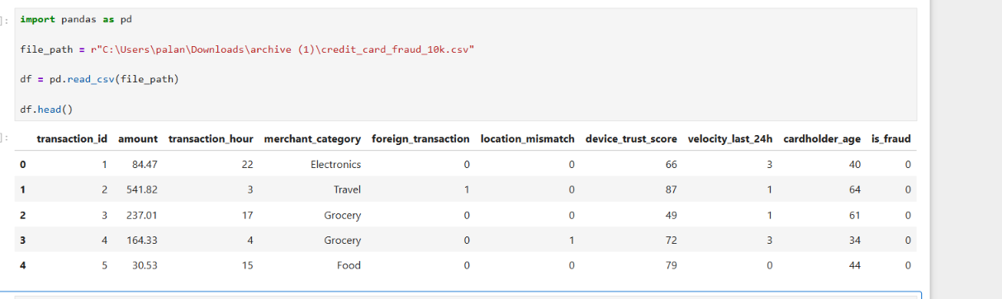

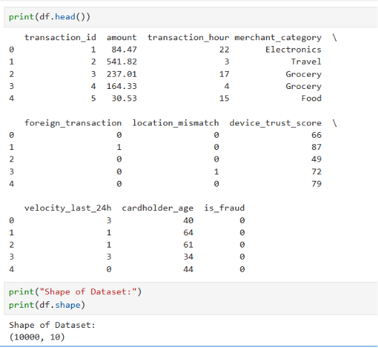

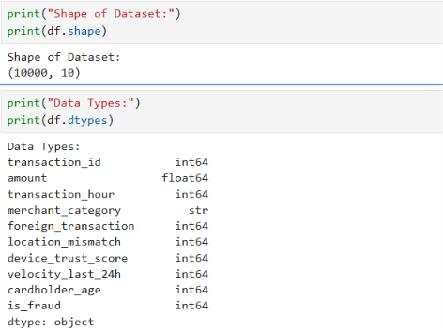

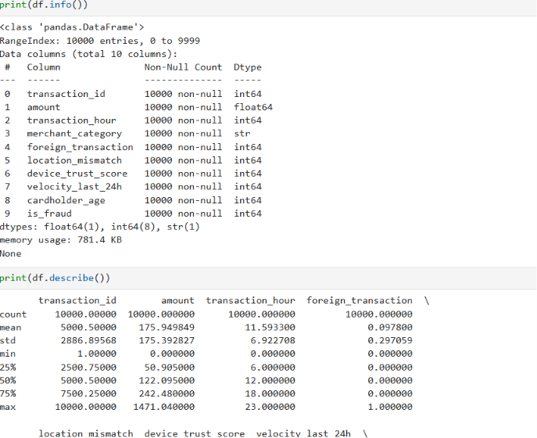
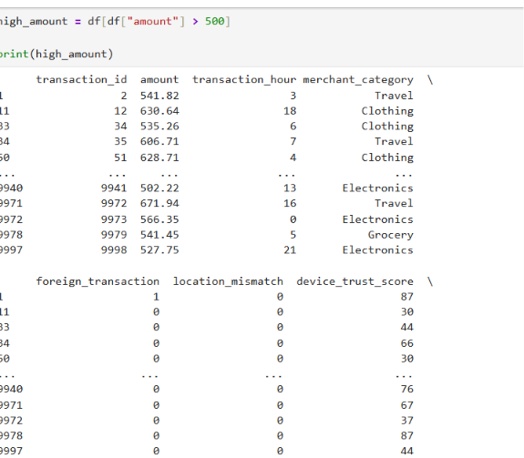
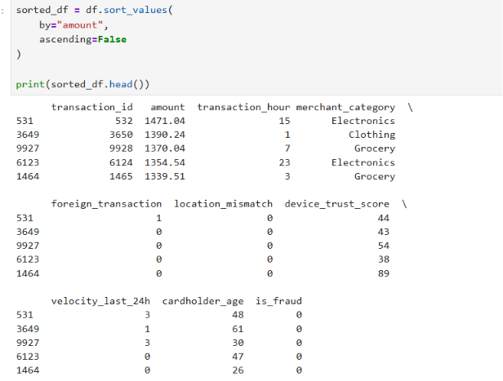
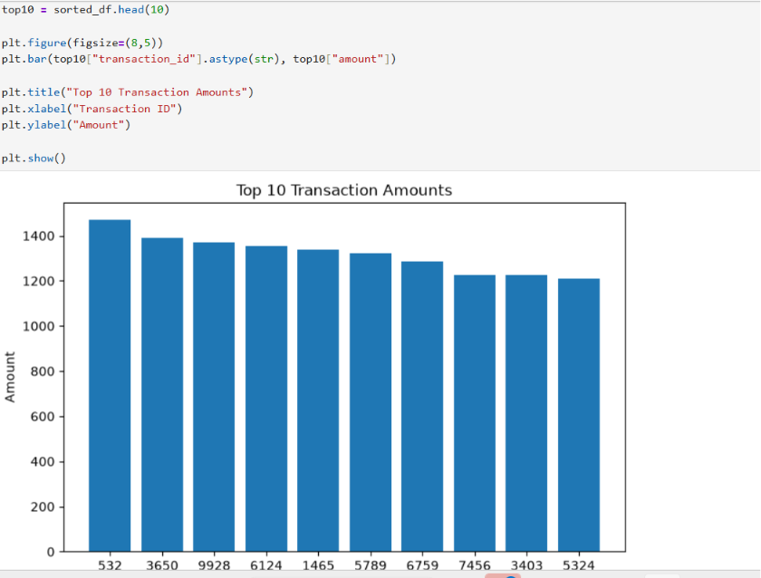
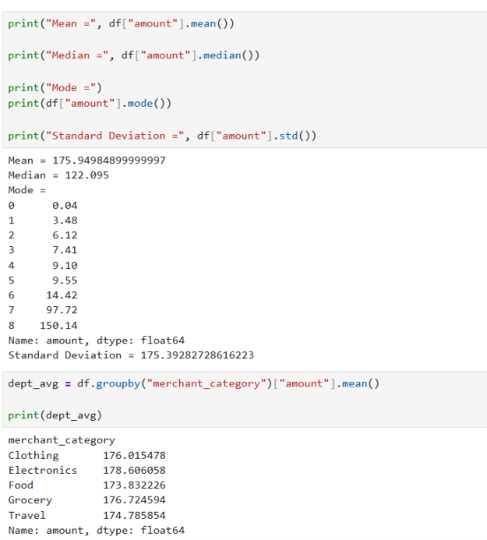
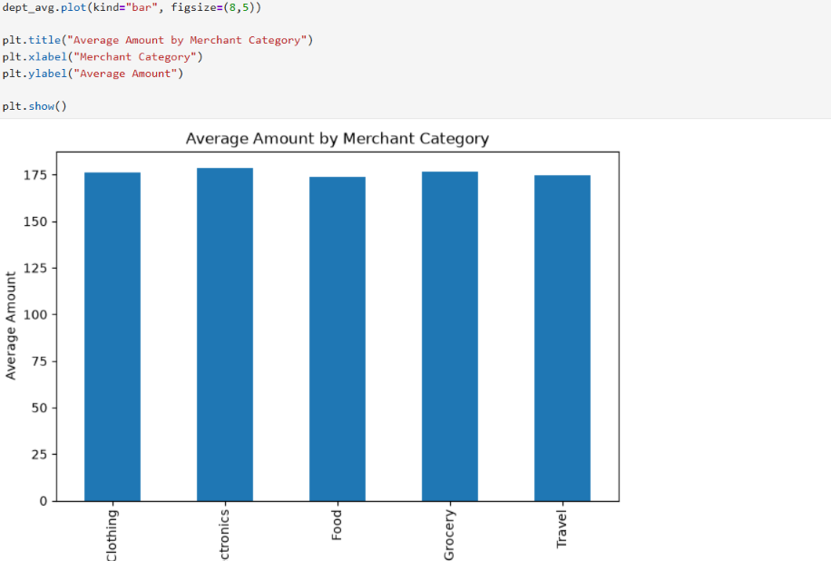
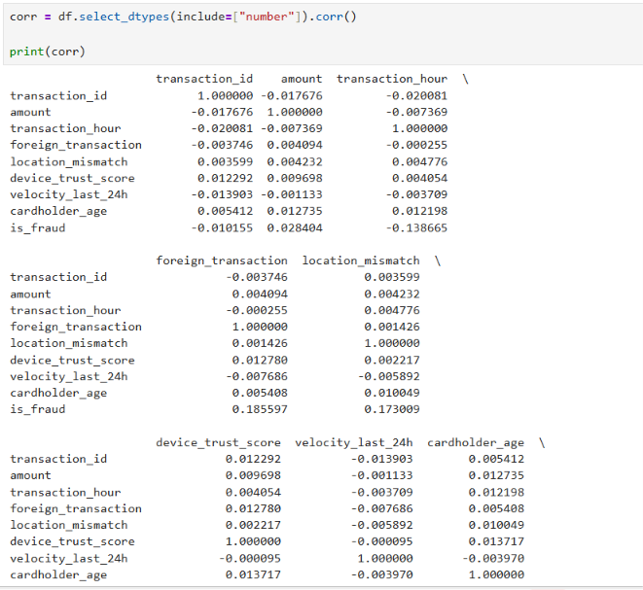
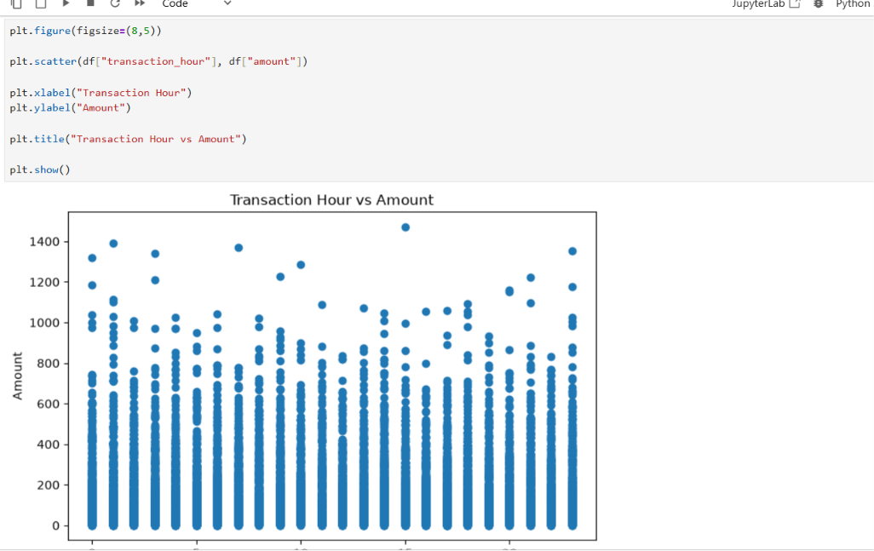

Result
Thus, the credit card fraud dataset was successfully inspected, filtered, statistically analyzed, grouped, visualized, and correlated using Python. The analysis identified high-value transactions, calculated important statistical measures, compared average transaction amounts across merchant categories, and examined relationships between numerical attributes and fraud.

